**Logistic Regression:**

Now lets us see some business problems where we need to predict the occurance of a event/happening of the event(probability of occurance of a event).So it results in two conclusions **yes** or **no.** example chancesof particular team winning the match, rainfall prediction, chances of breakdown of a car etc etc.

Now and also classification of a animal, fruit, etc etc.. we have a group of animals finding the cat among them. We have a basket of fruits finding the mango among them or simply a object is shown and saying which kind of object was that etc..etc

**All the above mentioned problems can be addressed using the Logistic Regression .**

So now we came to understand that logistic regression deals with data and gives only Boolean output for the prediction or conformational purpose and also used for the classification. Lets us go in detail now

Lets deal with probability: [P]

We know if probability is =1 then event if sure to happen

probability is =0.5 then event is having 50% to happen

probability is >0.5 then event has greater chances not to happen

We apply same logic here and map our data in between 0 and 1 as and see which cat falls under ***p<0.5*** and ***p>0.5****.* So after doing this we have a clear picture of estimation of any next event when given to the model which gives the output stating its oocurance to be **True/False.**

**LOGISTIC REGRESSION EXPLAINED IN TERMS OF *EXENDED LINEAR REGRESSION:***

Your complete idea on LinearRegression makes this a bit easy. So what we obtain in LinearRegression is line which gives the output when various inputs are fed at a instant.

Z=m1x1 +m2x2 +m3x3+ …….+c

So for every x1,x2,x3…… values there exist a y value …. For example the Z is rainfall variable and x1,x2…… are some features that are related to estimation of rainfall like the season, temperature, past year records of the day and so on.. After placing those values in equation we get Z .So we get rainfall variable that’s fine and its LinearRegression.

Now on basis of the rainfall variable obatained now we forecast wheather there will be rain fall or not. Lets hold the rainfall variable and be on that ….

***LOGISTIC FUNCTION:***

You can see the logistic function down and its explains that , Logistic function throws the probability between 0 and 1 for any valuevariable Z. So irrespective of value of Z(infinty,+infinity) we obtain probability value for that. 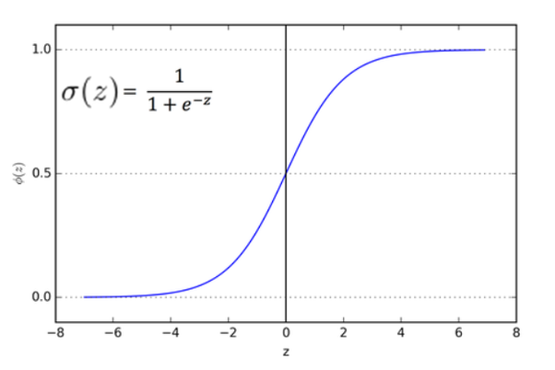

Now come back to our rainfall variable. So for every value of rainfall variable obtained the probability is obtained between 0 and 1. So for the variables whose probability values is >0.5 estimated to have rainfall at that day and < 0.5 are estimated to have no rainfall at that day.

After training our model when we give inputs of x1,x2…… of a future day and obtain Z value.

The z value is fed to logistic function and probability is observed(<0.5 or >0.5) and chances of rainfall on that future day is forecasted.

Go with some screenshots for details….

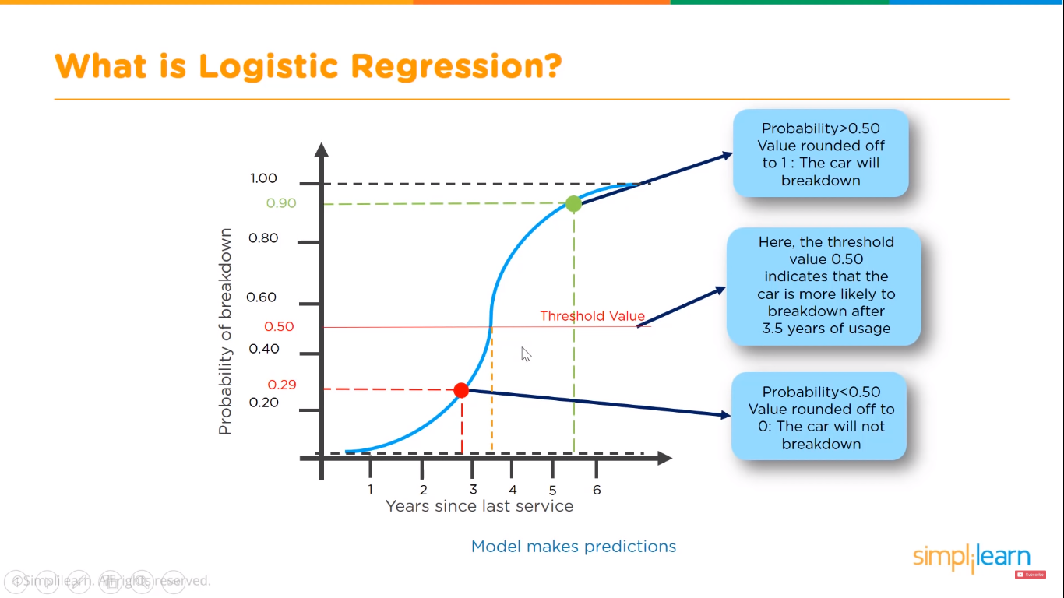

The below is linear data

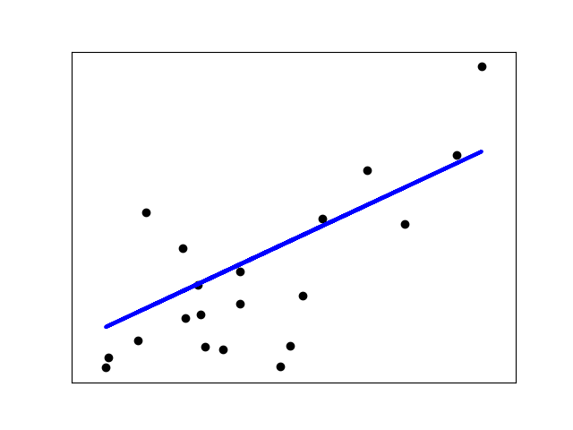

The linear data is now plotted in probability terms using logistic

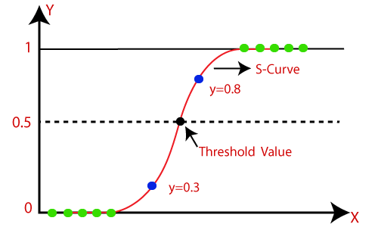

Value < 0.5 are False, No , Negative

Value >0.5 are True,Yes ,Positive

Like wise we can do match predictions, say an animal is of certain kind(yes/no), companies fall under profit or loss etc etc….